SIGNUP SCREEN

Exercise #02

Flutter Developer Bootcamp

# **Purpose**

This Exercise defines a Flutter screen for user signup. It includes input fields for name, number, and password, along with buttons for signup and social media login.

# **Problem**

The Flutter Exercise defines a signup screen with fields for name, phone number, and password, along with social media signup options. It's structured using a Scaffold, SingleChildScrollView, and Column, stacking UI elements vertically. The screen includes an image, text prompts, input fields, a signup button, social media icons, and a login prompt. Overall, it offers a straightforward user interface for account registration.

# **How to Solve**

1. Checkout the workshop from Git Repo:

git clone -b <user-branch> <repo-URL>

2. Open the root folder inside VS Code

3. To build the app click the run option in the main method { }

4. **Logo:**

* Centred image from a URL.

**5. Text Fields for User Input:**

* Name input field.
* Phone number input field.
* Password input field with visibility toggle icon.

**6. Signup Button:**

* Elevated button with "Sign Up" text.
* Full-width button with specified height.

**7. Social Media Login Buttons:**

* Icon buttons for Facebook, Google, and Apple.
* Centred horizontally in a row.

**8. Prompt to Log In:**

* Text prompting users to log in if they already have an account.

**9. Layout Structure:**

* Uses Column for vertical arrangement of widgets.
* Uses Row for horizontal arrangement of social media login buttons.
* SingleChildScrollView for making content scrollable.
* Padding for spacing around the main content.

# **You Will Achieve**

This Flutter code achieves the creation of a signup screen for a mobile application. Here's a breakdown of its key features:

1. **Scaffold and Styling**:
   * Uses Scaffold to create the basic visual structure of the screen.
   * The background colour is set to white.
2. **SingleChildScrollView**:
   * Ensures that the screen is scrollable, which is helpful when the keyboard appears or if the content overflows.
3. **Padding and Column**:
   * Uses Padding to add horizontal and vertical padding around the content.
   * Uses Column to arrange widgets vertically.
4. **Logo and Image**:
   * Centres an image at the top of the screen, which could be a logo or an illustration related to sign-up.
5. **Text Widgets**:
   * Displays a header ("Create Your Account") and a subheader ("Create an account so you can manage your personal finances.").
6. **Input Fields**:
   * Three TextField widgets for user input: name, phone number, and password.
   * The password field uses obscureText to hide the text input.
7. **Sign Up Button**:
   * A centred ElevatedButton for submitting the signup form.
8. **Social Media Signup Options**:
   * Displays a text ("Sign Up With") followed by three IconButton widgets for Facebook, Google, and Apple sign-up options.
9. **Login Redirect**:
   * Text at the bottom to redirect users who already have an account to the login page.

# **Screenshots**

## **Expected Output**

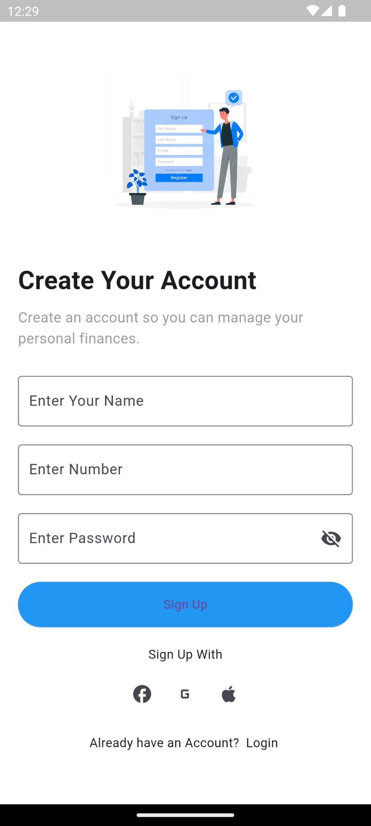

# **How to submit your Exercise**

Push your project back to the same git branch using command:

<command name>

# **Happy Coding!**